Hunter Johnson

Hjvd6

12480960

First of all, this entire final project creation was due to me, HUNTER JOHNSON. From setting up an AWS server and ensuring it could connect to the internet and installing the LAMP stack, to setting up the database and granting permissions, to actually coding the website’s functionality and style, it was me, HUNTER JOHNSON. Every file was written by me. My partner did not know how to do anything with web development and his contribution to the final project boiled down to creating the CREATE TABLE functions in SQL but even then, they didn’t include certain constraints and there were simple syntax errors in them that I had to fix. All functions were created by me and embedded in PHP statements to make them work. I have spent **A LOT** of time making this by myself, so please, if the website is not up to your standards please know that I had to do it all by myself and take pity on me. This is the exact reason I hate group projects. With that out of the way, here is how to use my website.

1. Create an account. The website requires that you make an account to access it. The user inputs the data into the form and sends it to the database and if successful will get this message. Then the user logs in with their information. 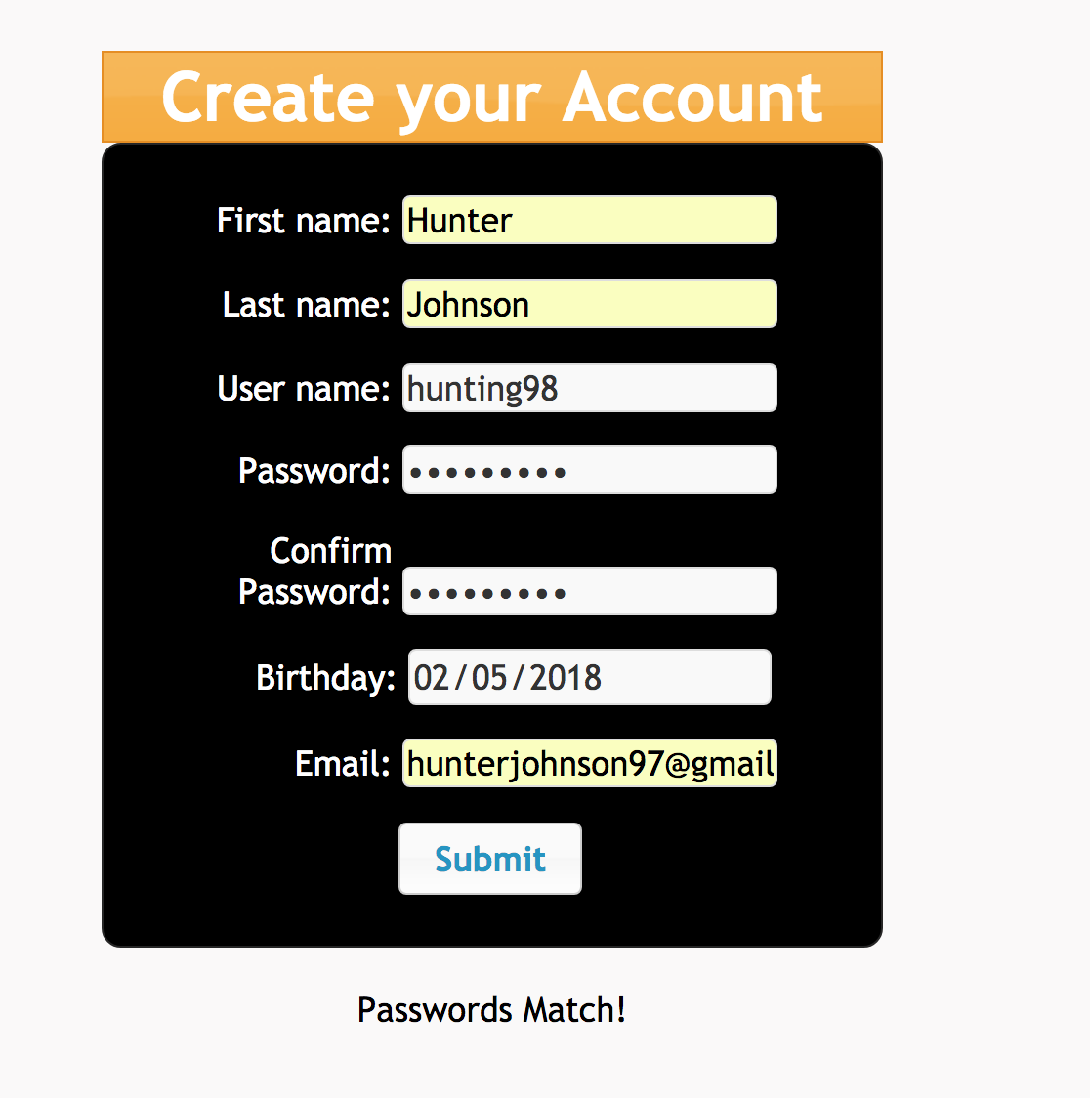

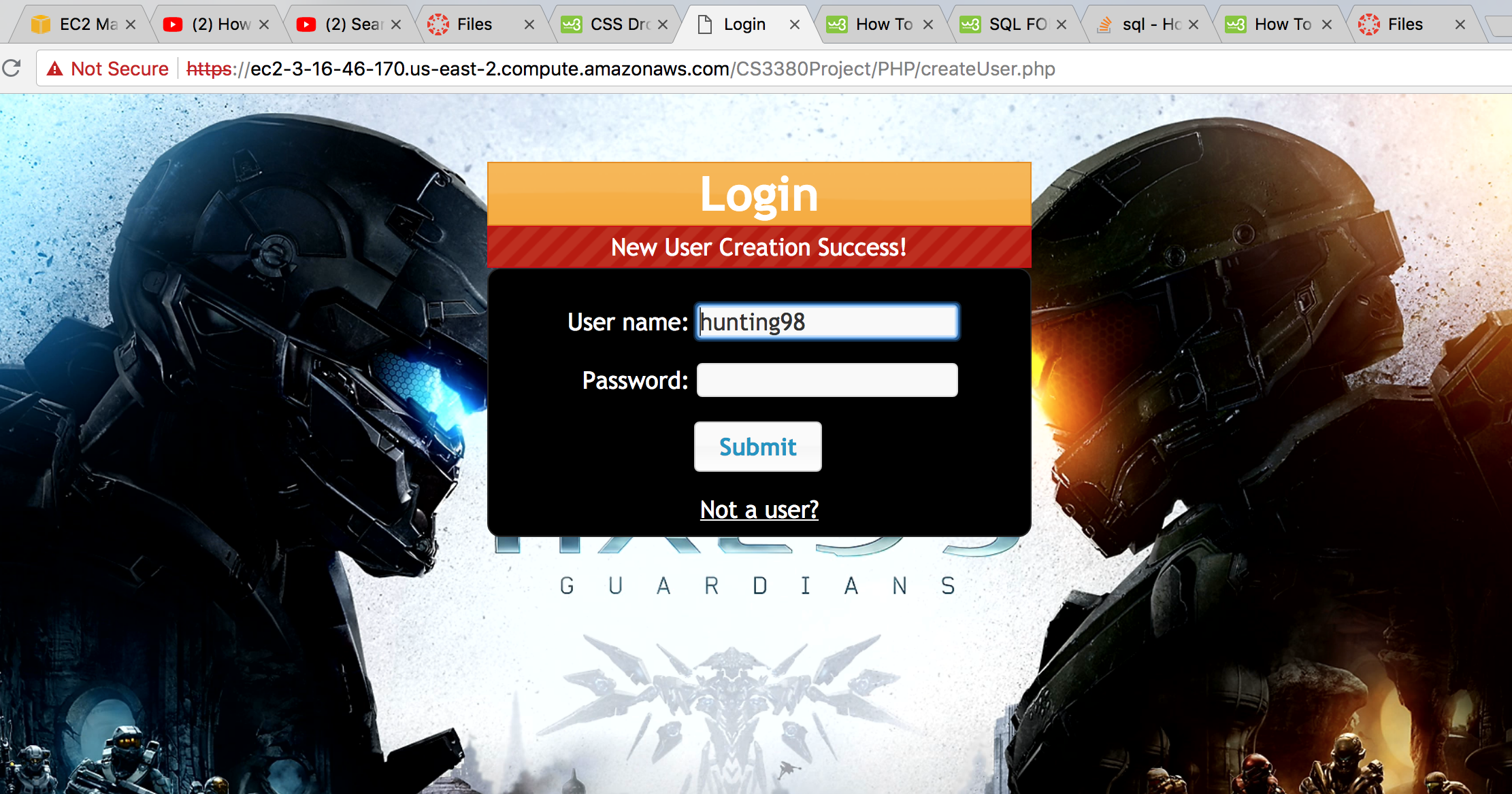

1. The user is then presented with the game of the month, in this case rainbow six siege. The user can type in the search bar a game they want to find. However, the game has to be exactly the name of the game in the database, there is no function to try and find the best match. Current games in the database include: Rainbow six Siege, Fallout 4. If the user types in a game that is not in the database, they will be confronted with confused John Travolta.

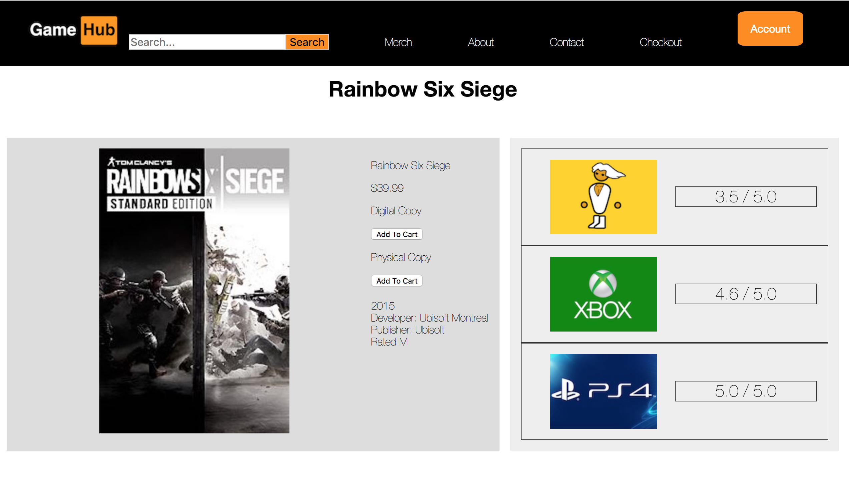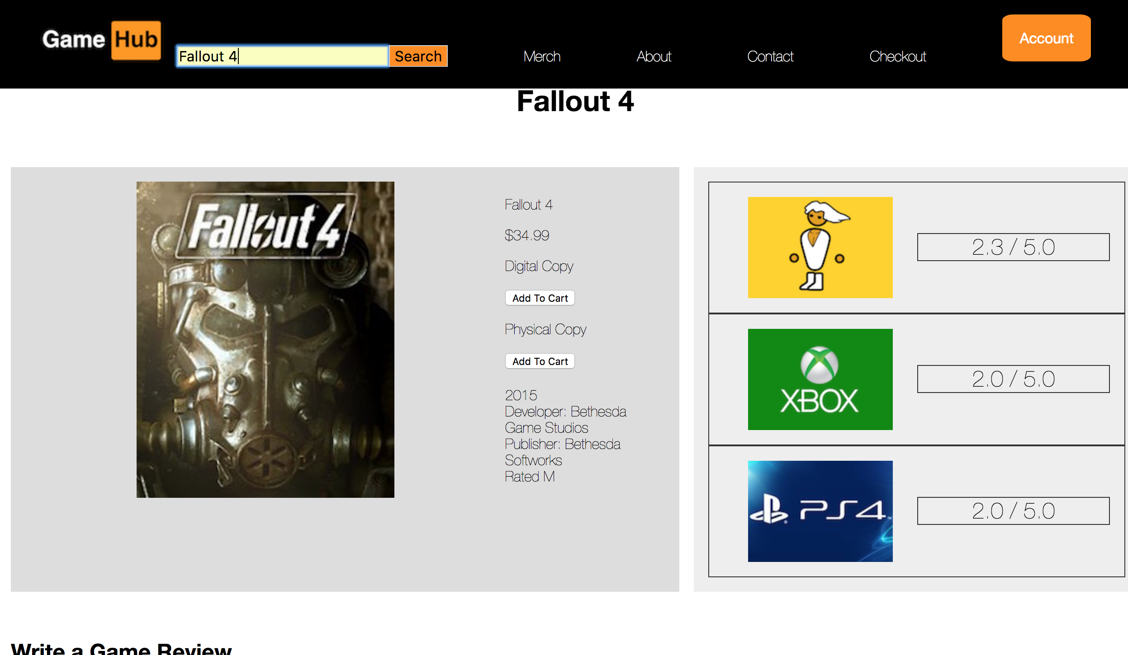

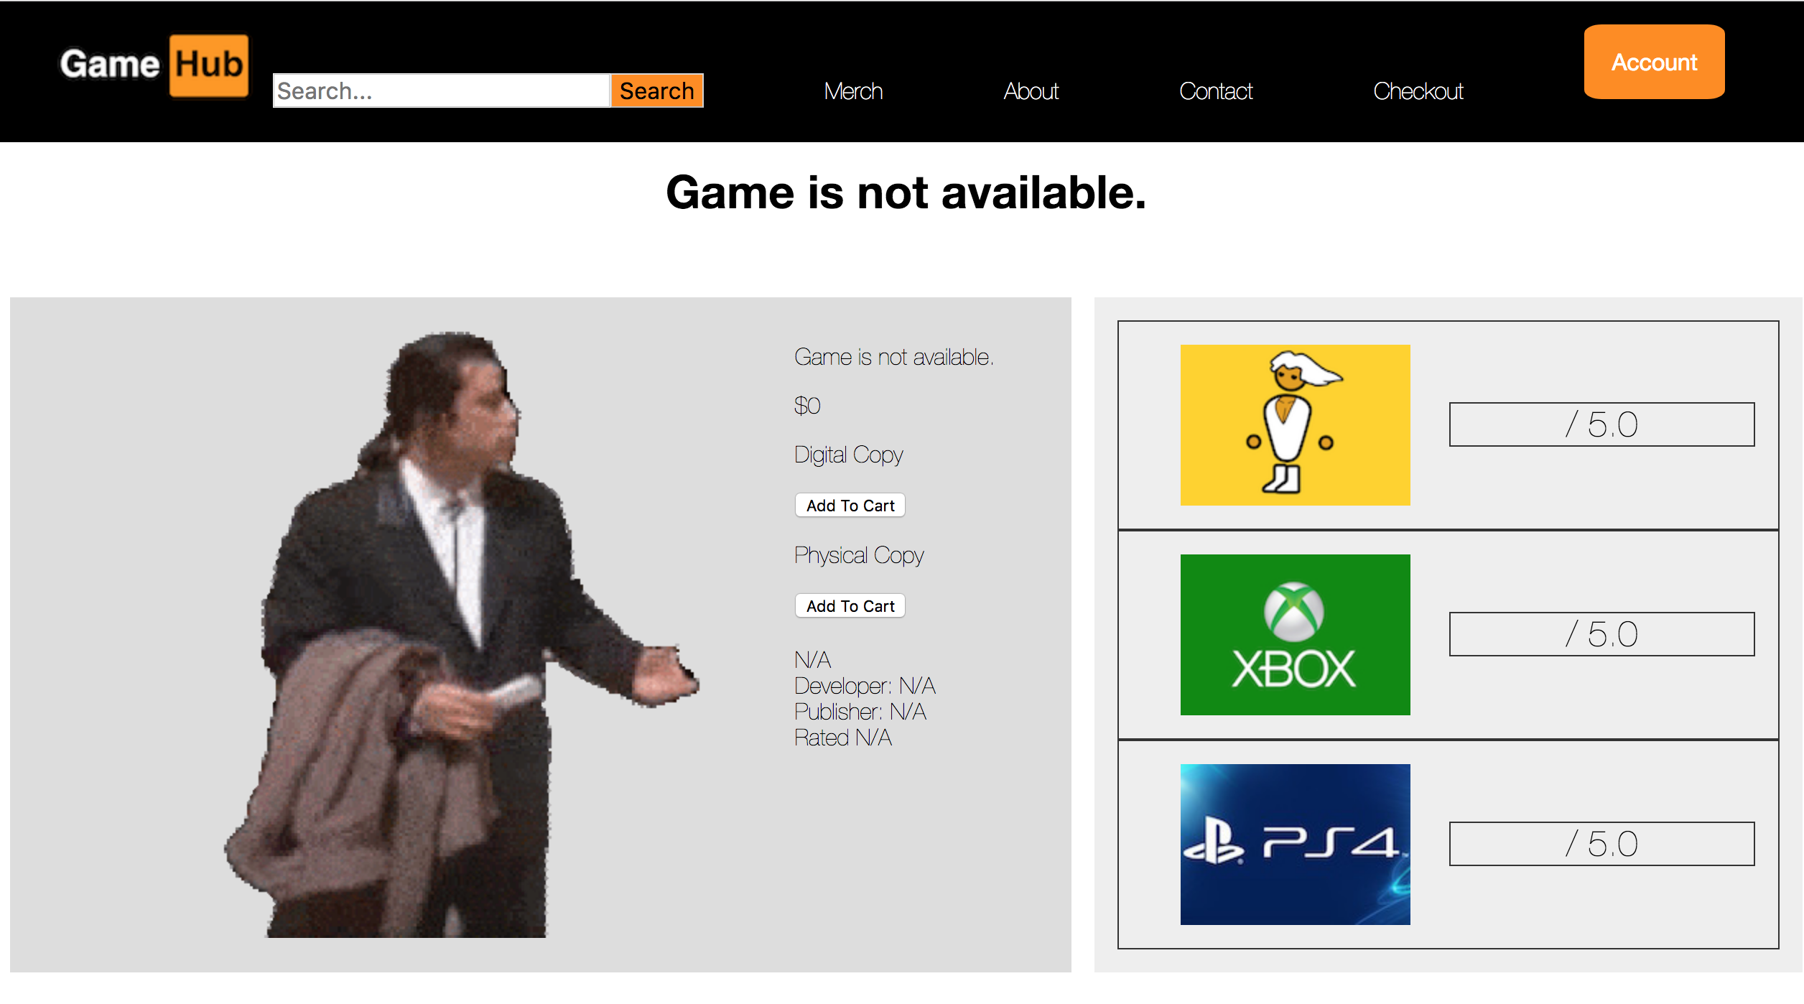

1. The user can write a review. The user has to select 1 of the three platforms, 1 of the 5 rating options and does not have to type anything in the review box. A user can only type 1 review per game + platform combination, so in total a user can have three reviews for 1 game, but they all have to be on separate platforms. Users can then hit the logout button to logout of the site.

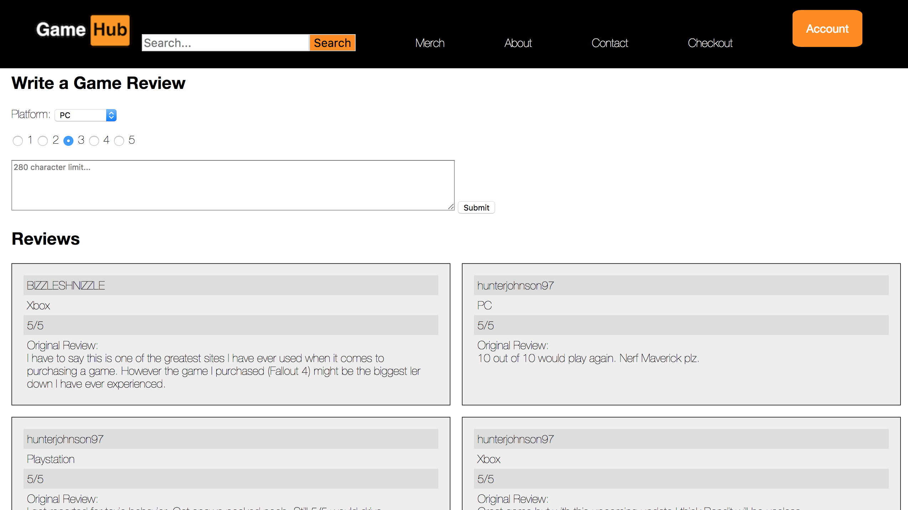

1. Every game page on this website is dynamic so when a user types in a game to search, in the background the PHP is sending requests to the database to populate the page with information pulled from the Games and Review tables. All the average ratings next to the game are generated using the AVG function of SQL and there is a limit of 6 reviews to be generated in descending order using the LIMIT and ORDER BY functions of SQL. Variables names are either stored as session variables or passed between PHP files. There are checks in place to ensure that before queries are sent to the database, they fulfill the requirements set by the database.
2. To add a game or a delete a user you can go to the admin section and type in your query.

IMPORTANT

The actual queries are embedded in PHP, so while there is an SQL file, this mainly boils down to creating the tables. Go into the individual PHP files to see the queries.